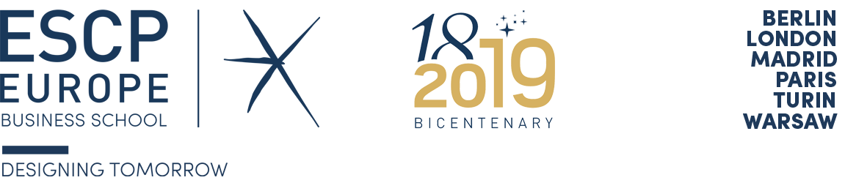

Dear Colleagues!

We are delighted to invite you to participate in the 16th International Human Resource Management Conference, which will take place on June 2-5, 2020 at ESCP Europe, Paris, France.
Over the last three decades, IHRM Conferences were held every two years at different locations all around the world such as Singapore, Hong Kong, Ashridge House (United Kingdom), Gold Coast (Australia), San Diego (United States of America), Paderborn (Germany), Limerick (Ireland), Cairns (Australia), Tallinn (Estonia), Santa Fe-New Mexico (United States of America), Birmingham (United Kingdom), Gurgaon (India), Krakow (Poland); Victoria-British Columbia (Canada), and Madrid (Spain).
For details, please visit our conference website: http://www.ihrm2020.org

The deadline for abstract submission is December 1, 2019.

Keynote speakers:

Prof. David Collings (Dublin City University Business School, Ireland)
Prof. Marion Festing (ESCP Europe, Berlin campus, Germany)
Prof. Alena Ledeneva (University College London School of Slavonic and East European Studies, United Kingdom)

For this 16th edition of the IHRM Conference, a PhD Workshop will be organized by the following convenors:

Prof. Dana Minbaeva (Copenhagen Business School, Denmark)
Prof. Helen De Cieri (Monash University, Australia)

We are looking forward to your participation in the 16th IHRM Conference and to welcoming you in Paris in June 2020, so please save the dates.

Conference Host Chair: Prof. Maral Muratbekova-Touron (ESCP Europe, Paris campus, France)

For any questions, do not hesitate to contact us at: IHRM2020@escpeurope.eu

